

100
Rural & Community
TOP HOSPITAL
2024

HOSPITAL NAME

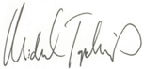
Michael Topchik, National Leader, The Chartis Center for Rural Health

