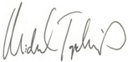

CATEGORY
Executive Director, Chartis Center for Rural Health
Top Quartile Performer Category
HOSPITAL NAME
PERFORMANCE
LEADERSHIP
AWARD 2025

